IDOG presents

Open Meetings in the Pandemic:
Setting the Record Straight

How to comply with the Idaho Open Meeting Law when meetings are virtual? What works? Best practices?
This session is intended for citizens, reporters, public officials and their staffs who are interested in the public's rights under Idaho law for access to public meetings in these extraordinary times.

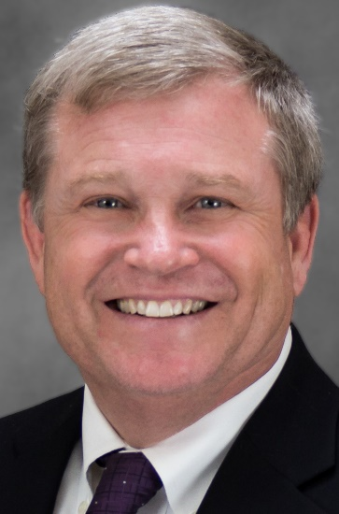
With:
Idaho Attorney General
Lawrence Wasden

Featuring:
* Deputy Attorney General Brian Kane
* Betsy Z. Russell, reporter, Idaho Press; president, Idahoans for Openness in Government (IDOG)

► Thurs. Jan. 7 – Online via GoToWebinar. Advance registration required. To register, go to https://attendee.gotowebinar.com/register/6596762315239876365.
Registrants are advised to check system requirements in
advance to avoid any connection issues.

FREE ADMISSION ~ PLEASE RSVP/REGISTER!
For more info, see www.openidaho.org

